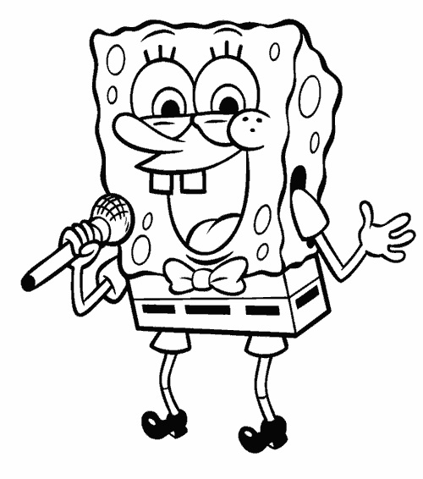

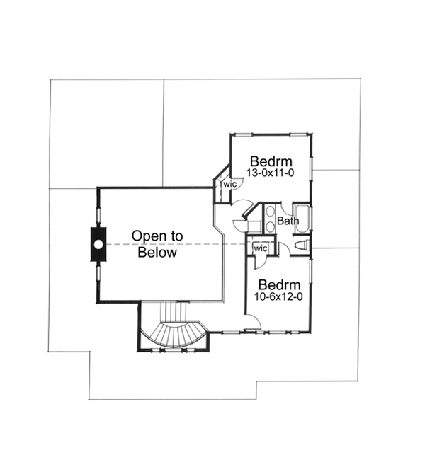

|  |  |
| --- | --- |
| **Caffeine** | **Sucrose** |
| http://2.bp.blogspot.com/-ltDl7ZDQuyg/UPRlqGsja8I/AAAAAAAARvg/f4pHKy4HtNE/s400/Name_This_Molecule_%2523197.bmp  **2R,3S-isocitre** | http://upload.wikimedia.org/wikipedia/commons/b/bd/Omethoate-Molecule-3D-balls-by-AHRLS.png  **Omethoate** |

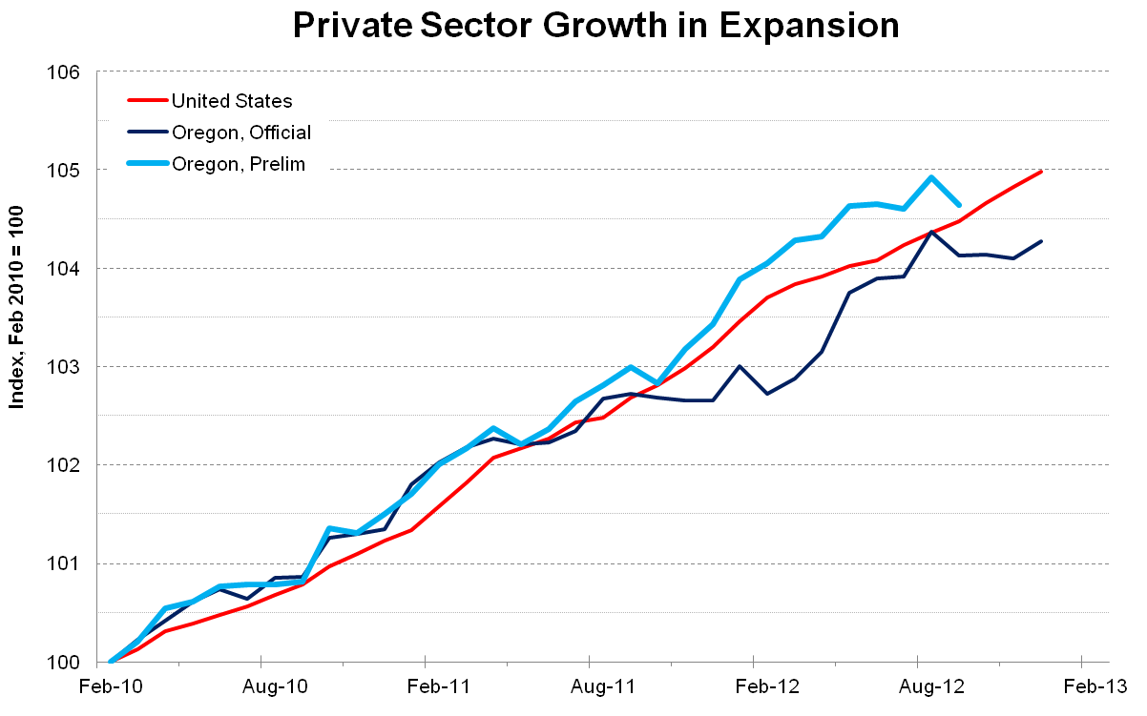

|  |  |
| --- | --- |
| C:\Users\jhincapie\Desktop\Projects\tPad\Docs\Experiment Goodies\HCI LAB.pnghttp://cs.umanitoba.ca/~hciweb/img/logo.png | C:\Users\jhincapie\Desktop\Projects\tPad\Docs\Experiment Goodies\ACM.org.pnghttp://www.acm.org/sigs/volunteer_resources/conference_manual/rz_acmlogo2.jpg |
| C:\Users\jhincapie\Desktop\Projects\tPad\Docs\Experiment Goodies\Google Calendar.pnghttp://fi.okfn.org/files/2013/05/google-calendar-logo.png | C:\Users\jhincapie\Desktop\Projects\tPad\Docs\Experiment Goodies\Google.png |